=

CLIENT: | Garber CDJR | PHONE #:
SPOT: | CJ-GAR-T210601 June Jeep Freedom | FAX # : | (NEW CAR)
LENGTH: | :30 | SALES REP: | Kim G.
DATE: | 6/16/2021 | PRODUCER | A. Dennis

GRAPHICS | Video | AUDIO
Garber Chrysler Logo  (Chrysler, Dodge, Jeep, Ram Logos)  www.GarberCDJR.com  Bay Road - Saginaw  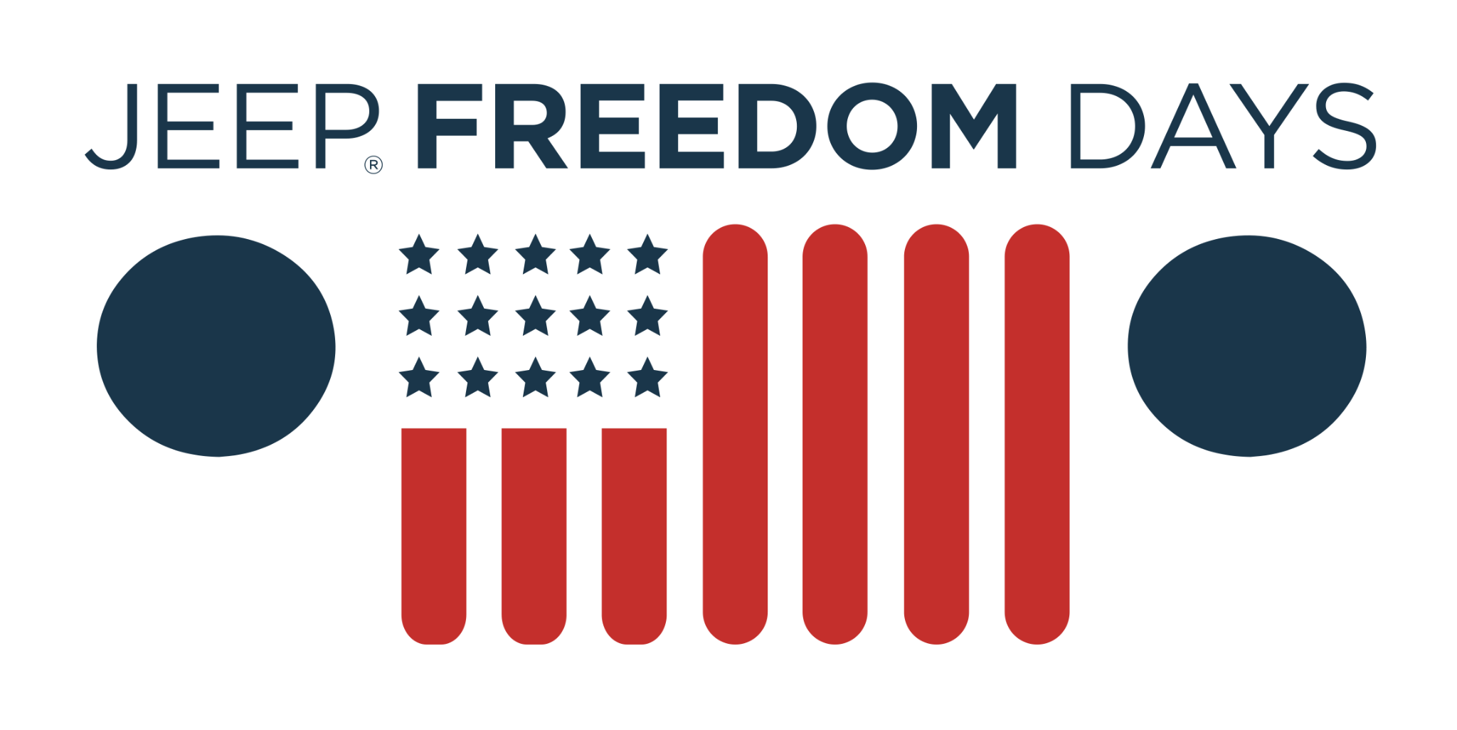  Over 165 Vehicles Arriving Soon  Reserve Now (Icon)  2021 Jeep Grand Cherokee Limited  Save Up To $7,000  Original MSRP $45,685. Stock# MC77764. Requires approved credit and financing through Chrysler Capital. Not all customers will qualify. Taxes, and optional equipment extra. Must qualify for Employee Pricing, Lease Loyalty, and First Responder rebates. Other restrictions apply. See dealer for details. Offer ends 7/3/21.  2021 Ram 1500 Big Horn  Lease From Just $294/mo  Stock# MN735544. Lease 36 months, 10,000 miles per year for qualified buyers with approved credit. $1,995 down. Tax, title, license fees extra. Must qualify for Employee Pricing, First Responder rebate, and Lease Loyalty. Other restrictions apply. See dealer for details. Offer ends 7/3/21.  Garber Chrysler Logo  (Chrysler, Dodge, Jeep, Ram Logos)  www.GarberCDJR.com  Bay Road - Saginaw | 2021 Jeep Freedom Days Event (Logo)  Photo: 2021 Jeep Grand Cherokee Limited  Photo: 2021 Ram 1500 Big Horn Quad Cab | Announcer: (:30)  Drive your own path toward incredible savings, during Jeep Freedom Days!  Now at Garber Chrysler Dodge Jeep Ram! Bay Road in Saginaw!  Get incredible deals on over 165 new vehicles arriving soon - ready for reservation!  Lock in a deal on a new Jeep Grand Cherokee today! Now with savings up to $7,000!  Or spend less on a new Ram 1500 Big Horn! Lease yours from just $294 a month!  Only at Garber Chrysler Dodge Jeep Ram! Bay Road in Saginaw!

